WP8 - Instrumentation & e-tools
Work package leader : Peter Willendrup (PW)

Venue : Bilbao
Date : May 28th 2019
Agenda :
9h00-9h10 | Welcome & agenda revision
9h10-9h30 | Status, remaining deliverables + milestones  - D8.17 (STFC/PSI) “Investigation of different test samples” PSI  - D8.18 (MTA-EK/Wigner) “Comparative Vitess+MCNP simulations” MTA-EK  - D8.19 (ESS-Bilbao) “Validation of the measurements by Monte Carlo simulations” ESS-B & PSI  - D8.20 (DTU) “Final release of all software” DTU  - MS5+MS6 Workshop DTU
9h30-10h30 | Presentations on work from currently delayed deliverables :  - D8.11 “Improved user interface” Erik B Knudsen  - D8.13 “Optimization study of selected instr using CombLayer and McStas-MCNP” Esben B Klinkby  - D8.16 “Activation studies, radiation resistance” Eszter Dian
10h30-11h00 | Coffee break
11h00-12h00 | - WP Working together on the GA presentation
12h00-12h30 | - ECNS workshop, AOB

List of participants – 11. participants in total - see last pages for the full list.
Photos :
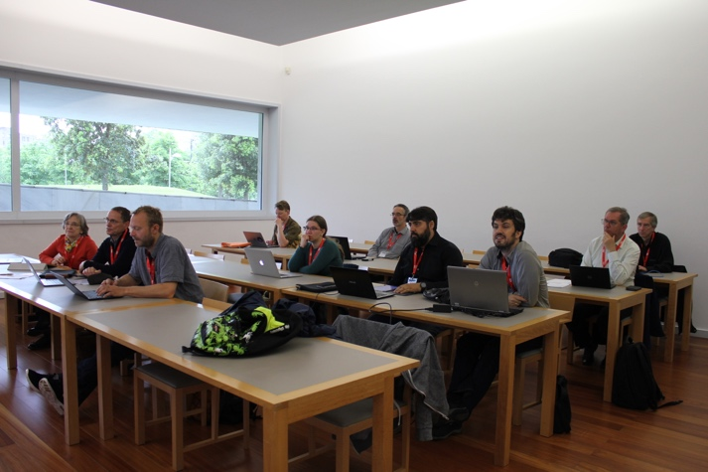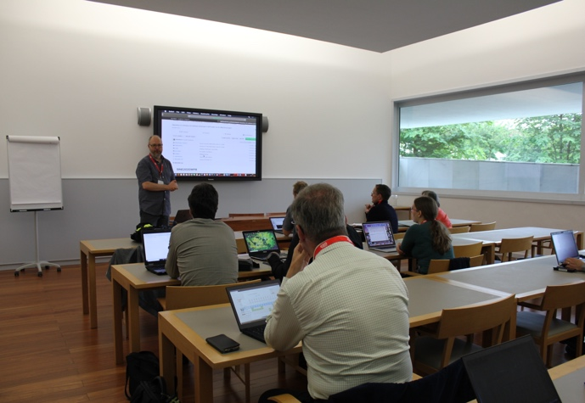

Detailed points incl discussion and outcome
9:00 Peter Willendrup (PW) welcomed the participants and the meeting agenda was accepted.
9:10 The WP discussed the remaining deliverables and milestones:
- D8.17 (STFC/PSI) “Investigation of different test samples” PSI and D8.19 (ESS-Bilbao) “Validation of the measurements by Monte Carlo simulations” ESS-B & PSI
Uwe Filges (UF) outlined that the experiment will be carried out at ChipIr mid-June and gave the WP access to a set of related slides from STFC (attached). UF and Miguel Magán (MM) noted that the experiment will be closely coordinated with ESS-B for D8.19 which will extend the earlier delivered work D8.5 on laminar shielding. UF further gave access to updated slides on the PSI manufacturing of Pb spheres for the BSS spectrometer.
- D8.18 (MTA-EK/Wigner) “Comparative Vitess+MCNP simulations” MTA-EK
Eszter Dian (ED) explained that staff from Wigner could not be present in the WP meeting but that work is under way to apply algorithms from Kolevatov[1] to Vitess simulations. PW noted that presence of the Wigner staff at the St. Petersburg workshop (see below) would ensure coherence across the WP deliverables.
- D8.20 (DTU) “Final release of all software” DTU
PW quickly showed that a GitHub repository is under way and. The WP provided suggestions on other types of information that could be included.
- MS5+MS6 Workshop DTU
PW explained that a workshop website is available and that the agenda is finalized. A few open seats are still available. PW and Katia Pappas (KP) explained that the editor of JNR has suggested we publish our work / proceedings from the workshop in a dedicated issue. The contributions must be submitted before the end of SINE2020, i.e. during September. MM explained that due to the ESS-B TDR and other meetings, MM and Octavio Gonzales (OG) can not be present at the workshop, and it was agreed that Esben Bryndt Klinkby (EBK1) will stand-in to present the work in St. Petersburg. The intended workshop presentation was provided for EBK1 and the WP.
9:30 Presentations on work from currently delayed deliverables :
- D8.16 “Activation studies, radiation resistance” Eszter Dian
ED gave a presentation (attached) on the status of the MTA-EK work on activation, the results of which are being written up for publication. The presentation showed that the actual material compositions for our shielding materials may in subtle ways differ from what is listed from the supplier and that these small differences lead to substantial differences in material activation. The presentation showed convincing results of comparisons between measured activations and MCNP simulations done in collaboration with EBK2, tuned to the new insight into material compositions. The deliverable report is expected in connection with the workshop in St. Petersburg.
- D8.11 “Improved user interface” Erik Bergbäck Knudsen (EBK2)
EBK2 gave a presentation (attached) explaining how he will ensure that the software and algorithms developed in Task 8.1 becomes available to the general public in the form of fully documented examples on GitHub. A first version of the repository and related deliverable report is expected in connection with the workshop in St. Petersburg.
MM and PW explained that feedback from LANL wrt. licensing and conditions for release of the MCNP patches was still pending, but re-iterated earlier in May.
- D8.13 “Optimization study of instr using CombLayer and McStas-MCNP” Esben B Klinkby
EBK1 gave a presentation (attached) giving a status of an ongoing comparison project for models of BIFROST@ESS using CombLayer (geometry engine for MCNP models), the supermirror patch for MCNP from D8.3, MCPL from D8.2 and McStas. Discrepancies are being investigated with the aim of preseting the final results at the workshop in St. Petersburg. The deliverable report also expected in connection with the workshop.
10:30 Coffee/ Tea Break
11:00 WP Working together on the GA presentation
- PW gave a presentation of the slides intended for the GA and the WP provided feedback
12:00 Workshop and AOB
- Practicalities wrt. the St. Petersburg workshop, the planned publications for JNR and the remaining deliverables were discussed. Once the St. Petersburg meeting has been held, we
will decide if there will be a final meeting at the end of SINE, e.g. at DTU.
End of minutes.

Participant list:
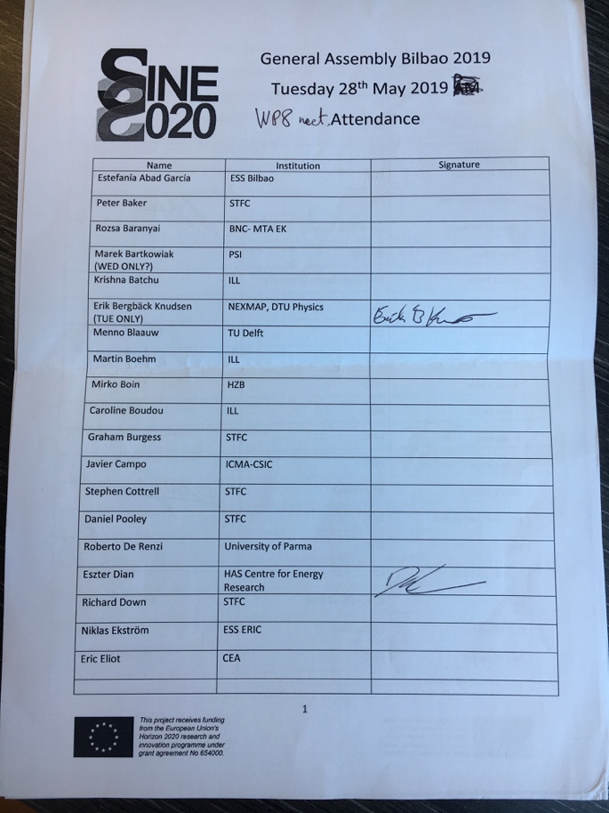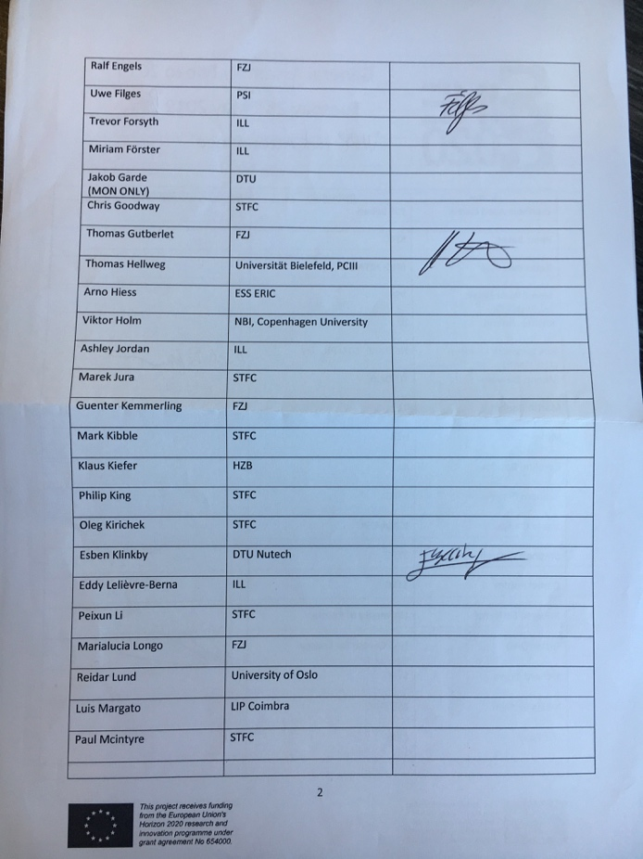
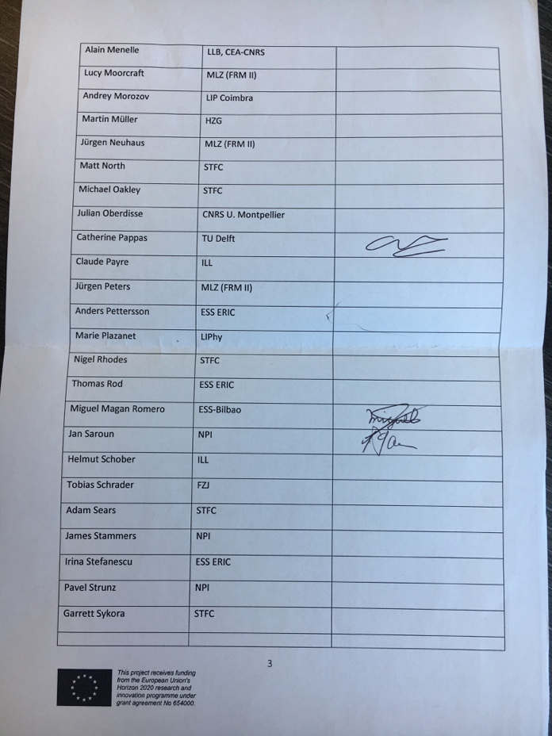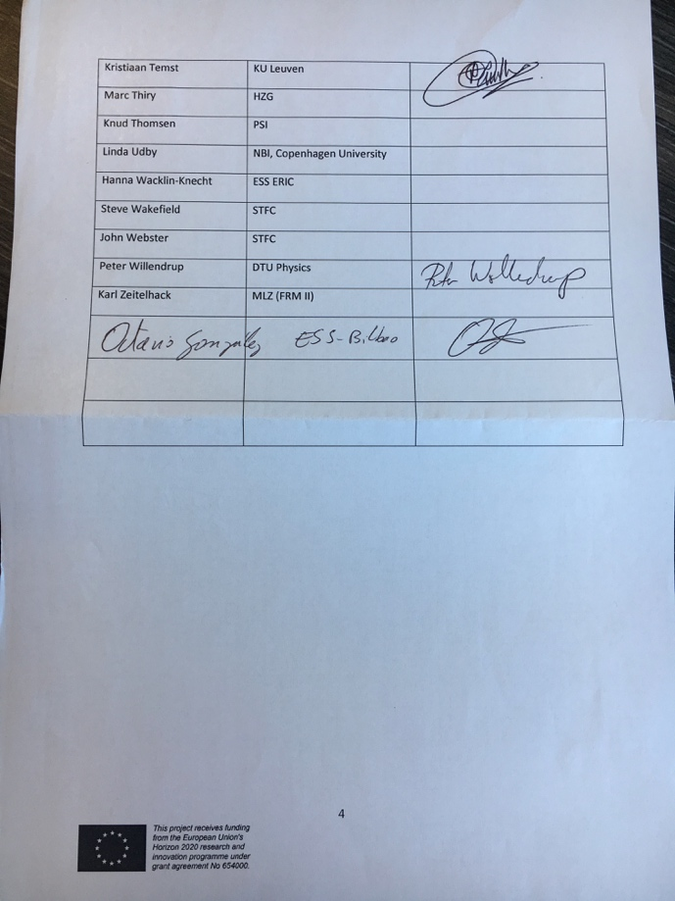

[1] R Kolevatov et. al. NIM A 922 (2019) pp. 98-107

